App.java

package com.spring.SpringFramework;

import org.springframework.context.ApplicationContext;

import org.springframework.context.support.ClassPathXmlApplicationContext;

public class App {

public static void main(String[] args) {

ApplicationContext context = new ClassPathXmlApplicationContext("spring.xml");

Vehicle obj = (Vehicle)context.getBean("vehicle");

obj.drive();

}

}

Car.java

package com.spring.SpringFramework;

public class Car implements Vehicle {

public void drive() {

System.***out***.println("car is running");

}

}

Bike.java

package com.spring.SpringFramework;

public class Bike implements Vehicle {

public void drive() {

System.***out***.println("Bike is running");

}

}

Vehicle.java

package com.spring.SpringFramework;

public interface Vehicle {

void drive();

}

spring.xml

<?xml version="1.0" encoding="UTF-8"?>

<beans xmlns = "http://www.springframework.org/schema/beans"

xmlns:xsi = "http://www.w3.org/2001/XMLSchema-instance"

xsi:schemaLocation = "http://www.springframework.org/schema/beans

http://www.springframework.org/schema/beans/spring-beans.xsd">

<bean id="vehicle" class="com.spring.SpringFramework.Car"></bean>

</beans>

Annotation based dependency injection

package com.spring.SpringFramework;

import org.springframework.context.ApplicationContext;

import org.springframework.context.support.ClassPathXmlApplicationContext;

public class App {

public static void main(String[] args) {

ApplicationContext context = new ClassPathXmlApplicationContext("spring.xml");

Vehicle obj = (Vehicle)context.getBean("bike");

obj.drive();

}

}

Car.java

package com.spring.SpringFramework;

import org.springframework.stereotype.Component;

*@Component*

public class Car implements Vehicle {

public void drive() {

System.***out***.println("Car is running");

}

}

Spring.xml

<?xml version="1.0" encoding="UTF-8"?>

<beans xmlns="http://www.springframework.org/schema/beans"

xmlns:xsi="http://www.w3.org/2001/XMLSchema-instance"

xmlns:context="http://www.springframework.org/schema/context"

xsi:schemaLocation="http://www.springframework.org/schema/beans

http://www.springframework.org/schema/beans/spring-beans.xsd

http://www.springframework.org/schema/context

http://www.springframework.org/schema/context/spring-context.xsd">

<context:component-scan base-package="com.spring.SpringFramework"></context:component-scan>

<!-- Define other beans or configurations as needed -->

</beans>

Bean property:  
package com.spring.SpringFramework;

import org.springframework.context.ApplicationContext;

import org.springframework.context.support.ClassPathXmlApplicationContext;

public class App {

public static void main(String[] args) {

ApplicationContext context = new ClassPathXmlApplicationContext("spring.xml");

/*

* Vehicle obj = (Vehicle)context.getBean("bike"); obj.drive();

*/

Tyre t = (Tyre)context.getBean("tyre");

// t.setBrand("MRF");

System.out.println(t);

}

}

Tyre.java

package com.spring.SpringFramework;

public class Tyre {

private String brand;

public String getBrand() {

return brand;

}

public void setBrand(String brand) {

this.brand = brand;

}

*@Override*

public String toString() {

return "Tyre [brand=" + brand + "]";

}

}

Spring.xml

<?xml version="1.0" encoding="UTF-8"?>

<beans xmlns="http://www.springframework.org/schema/beans"

xmlns:xsi="http://www.w3.org/2001/XMLSchema-instance"

xmlns:context="http://www.springframework.org/schema/context"

xsi:schemaLocation="http://www.springframework.org/schema/beans

http://www.springframework.org/schema/beans/spring-beans.xsd

http://www.springframework.org/schema/context

http://www.springframework.org/schema/context/spring-context.xsd">

<context:component-scan base-package="com.spring.SpringFramework"></context:component-scan>

<!-- Define other beans or configurations as needed -->

<bean id="tyre" class="com.spring.SpringFramework.Tyre">

<property name="brand" value="MRF"></property>

</bean>

</beans>

Constructor injection:

Just add constructor in Tyre.java:

public Tyre(String brand) {

super();

this.brand = brand;

}

And add constructor-arg in spring.xml:

<bean id="tyre" class="com.spring.SpringFramework.Tyre">

<!--<property name="brand" value="MRF"></property>-->

<constructor-arg value="MRF"></constructor-arg>

</bean>

Autowired annotations:

App.java

package com.spring.SpringFramework;

import org.springframework.context.ApplicationContext;

import org.springframework.context.support.ClassPathXmlApplicationContext;

public class App {

public static void main(String[] args) {

ApplicationContext context = new ClassPathXmlApplicationContext("spring.xml");

Car obj = (Car)context.getBean("car");

obj.drive();

}

}

Car.java

package com.spring.SpringFramework;

import org.springframework.beans.factory.annotation.Autowired;

import org.springframework.stereotype.Component;

*@Component*

public class Car implements Vehicle {

*@Autowired*

private Tyre tyre;

public Tyre getTyre() {

return tyre;

}

public void setTyre(Tyre tyre) {

this.tyre = tyre;

}

public void drive() {

System.***out***.println("Car" + tyre);

}

}

Tyre.java

package com.spring.SpringFramework;

import org.springframework.stereotype.Component;

*@Component*

public class Tyre {

private String brand;

public String getBrand() {

return brand;

}

public void setBrand(String brand) {

this.brand = brand;

}

*@Override*

public String toString() {

return "It is working...";

}

}

Configuration Bean:  
App.java

package com.spring.SpringFramework;

import org.springframework.context.ApplicationContext;

import org.springframework.context.annotation.AnnotationConfigApplicationContext;

public class App {

public static void main(String[] args) {

ApplicationContext factory = new AnnotationConfigApplicationContext(AppConfig.class);

Samsung s7 = factory.getBean(Samsung.class);

s7.config();

}

}

Samsung.java

package com.spring.SpringFramework;

import org.springframework.beans.factory.annotation.Autowired;

public class Samsung {

*@Autowired*

MobileProcessor cpu;

public MobileProcessor getCpu() {

return cpu;

}

public void setCpu(MobileProcessor cpu) {

this.cpu = cpu;

}

public void config() {

System.***out***.println("Octa core, 4gb ram");

cpu.process();

}

}

AppConfig.java

package com.spring.SpringFramework;

import org.springframework.context.annotation.Bean;

import org.springframework.context.annotation.Configuration;

*@Configuration*

public class AppConfig {

*@Bean*

public Samsung getPhone() {

return new Samsung();

}

*@Bean*

public MobileProcessor getProcessor() {

return new Snapdragon();

}

}

MobileProcessor.java

package com.spring.SpringFramework;

public interface MobileProcessor {

void process();

}

Snapdragon.java

package com.spring.SpringFramework;

public class Snapdragon implements MobileProcessor {

*@Override*

public void process() {

// **TODO** Auto-generated method stub

System.***out***.println("WOrld best CPu");

}

}

Spring Edureka:

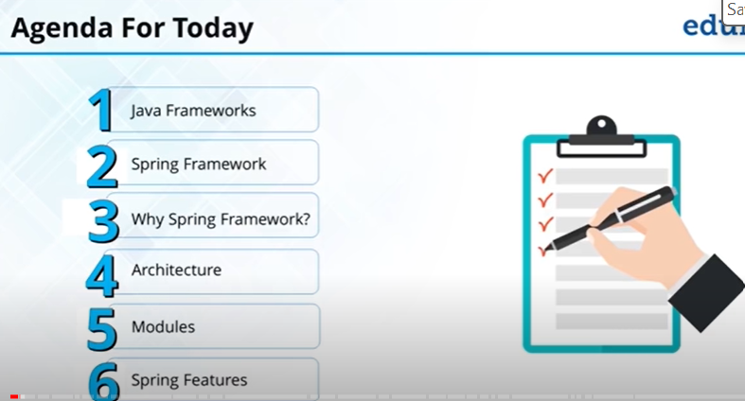

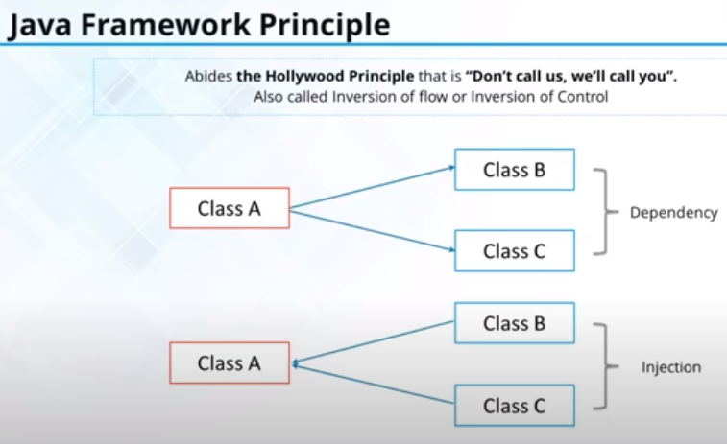

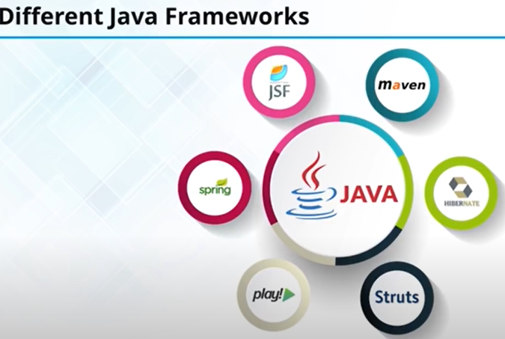

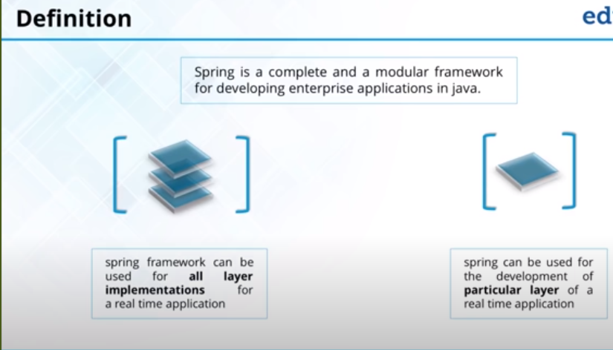

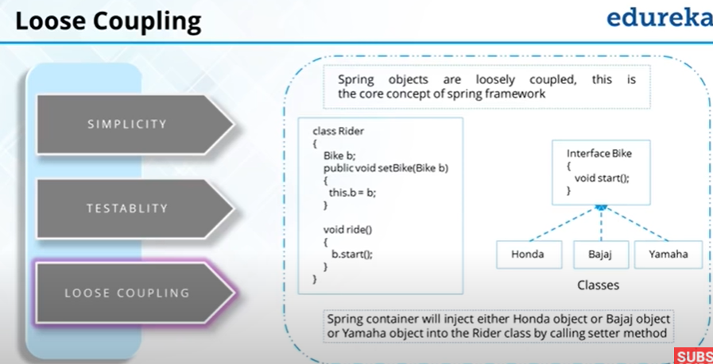

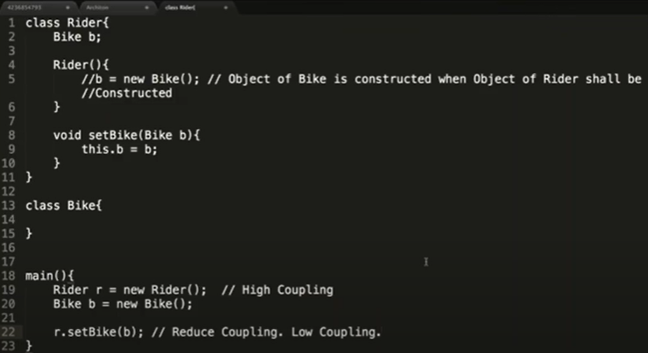

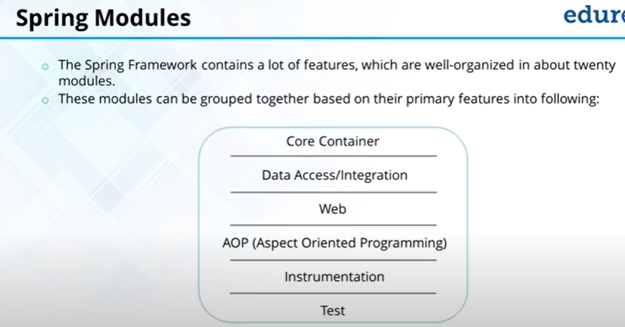

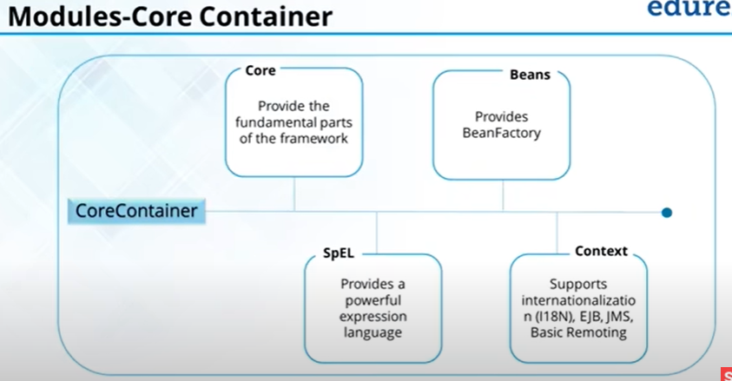

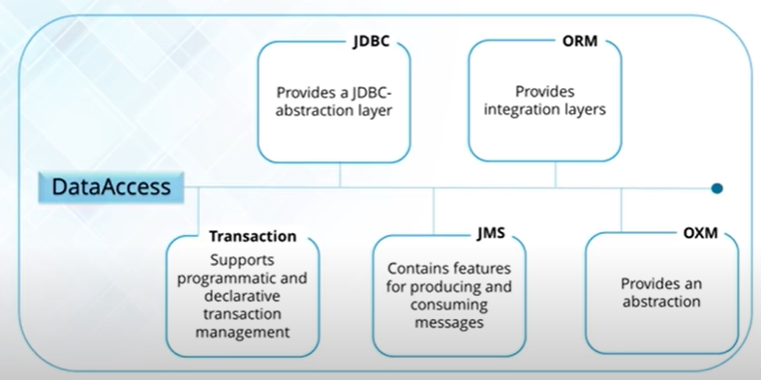

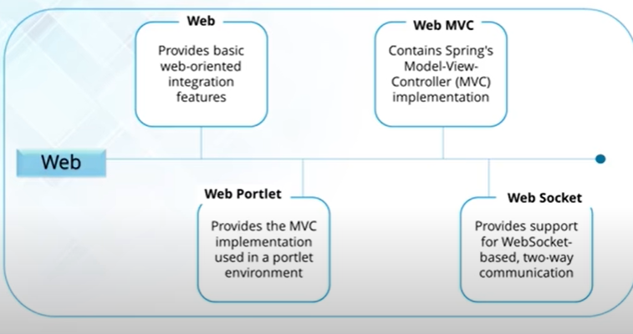

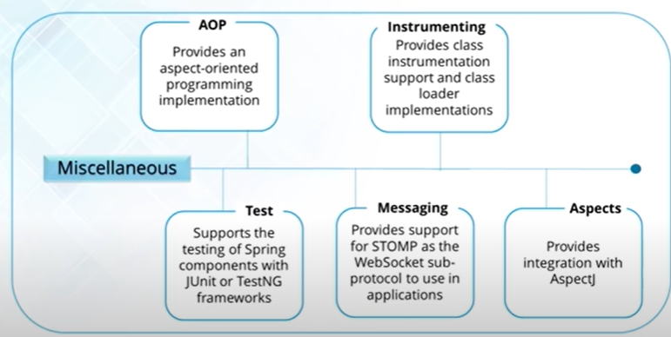

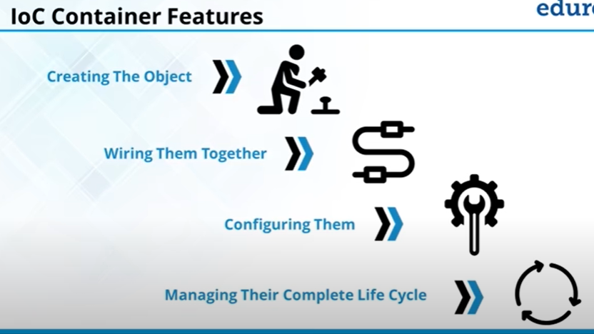

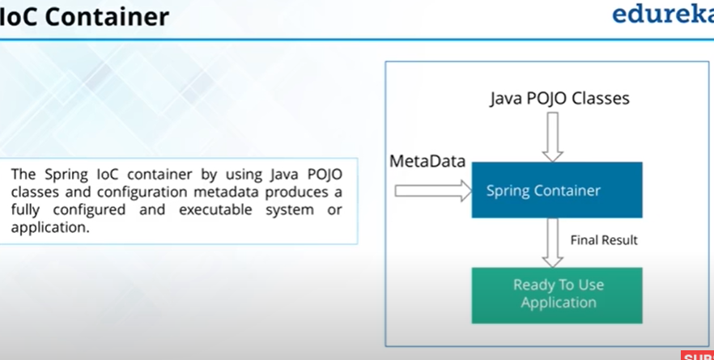

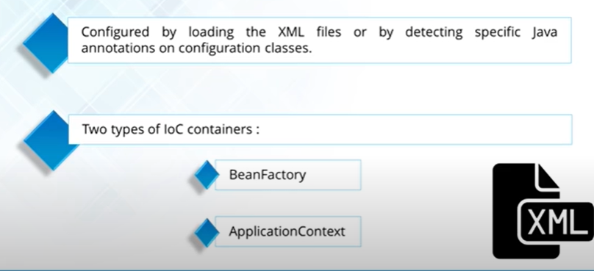

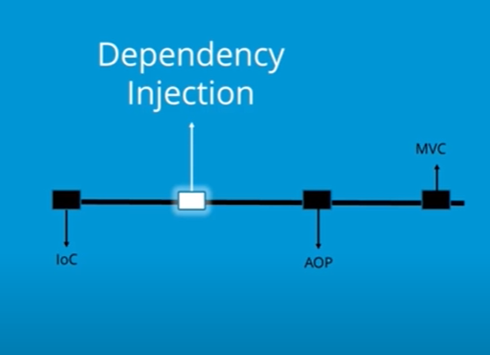

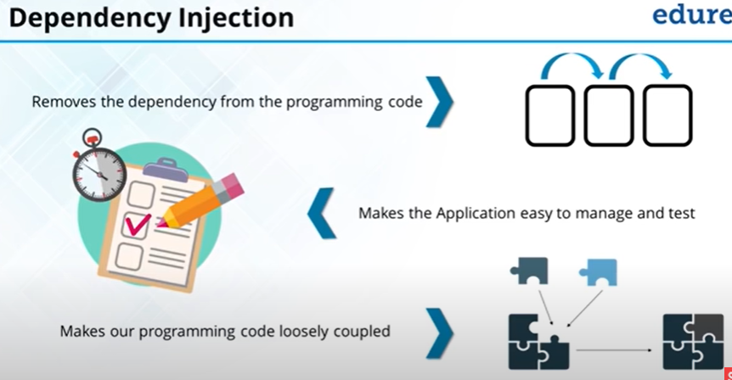

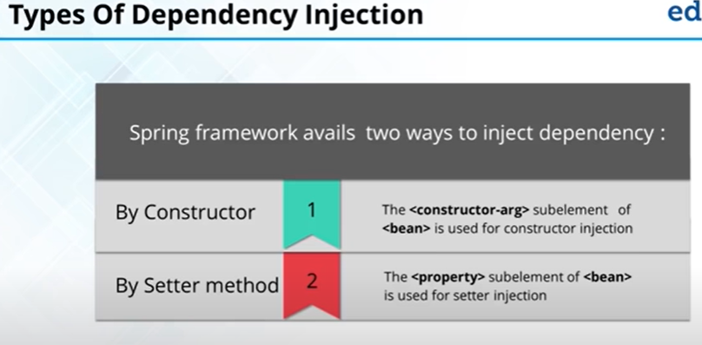

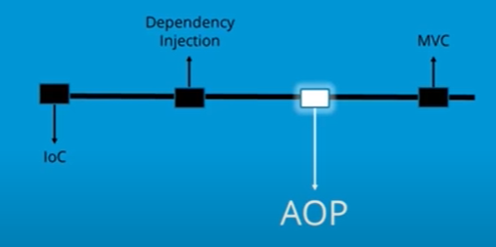

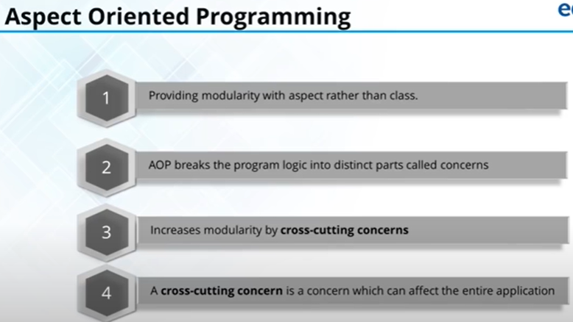

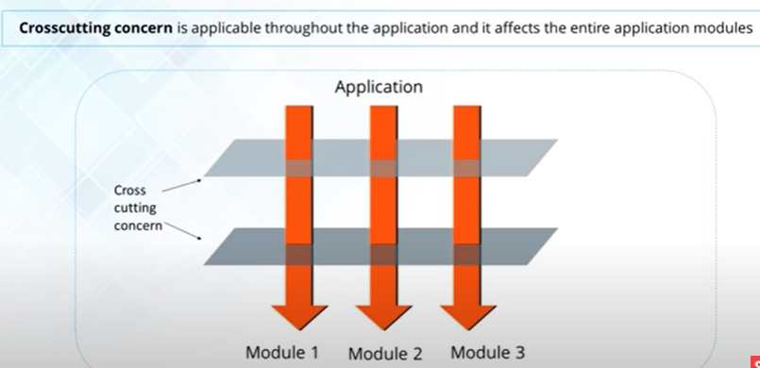

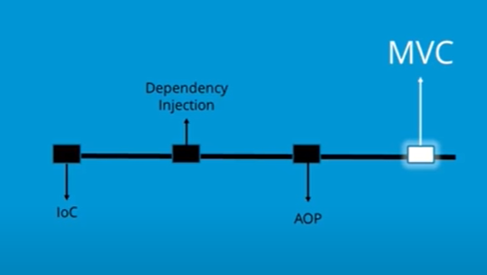

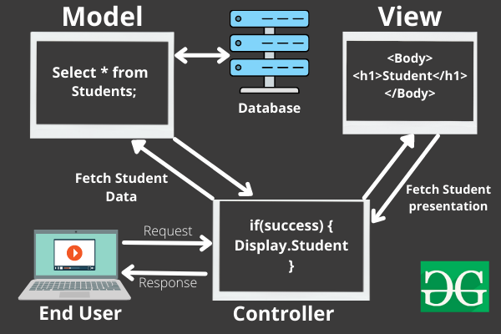

Example:

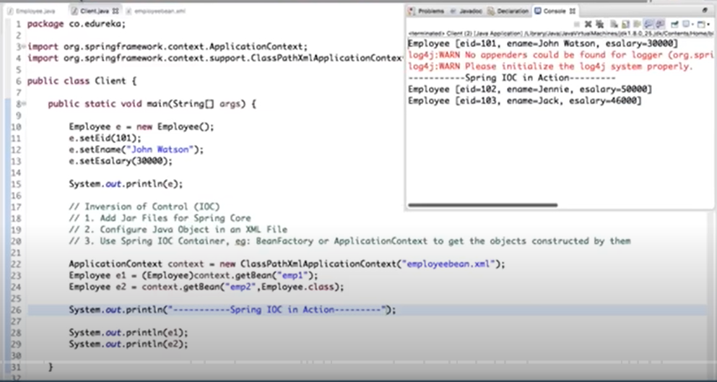

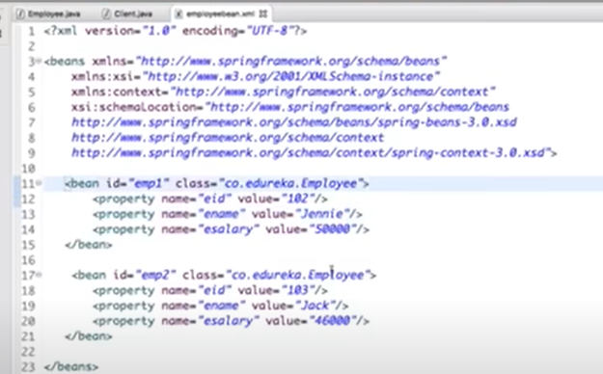

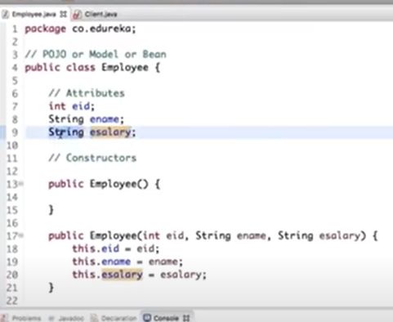 Add constructor and to_string and getter and setters for the class Employee.

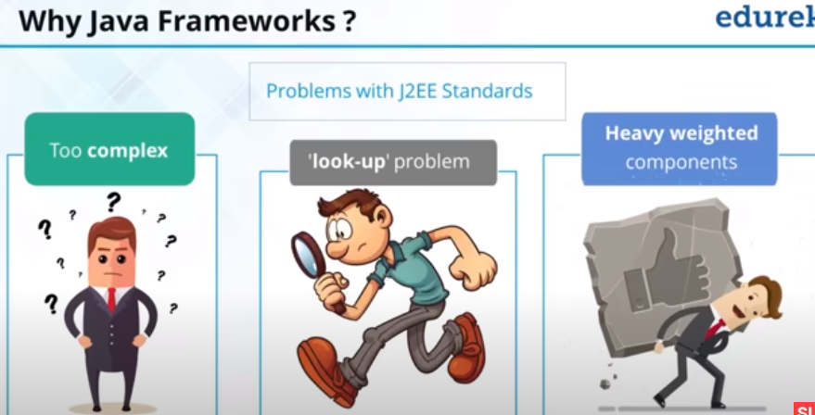

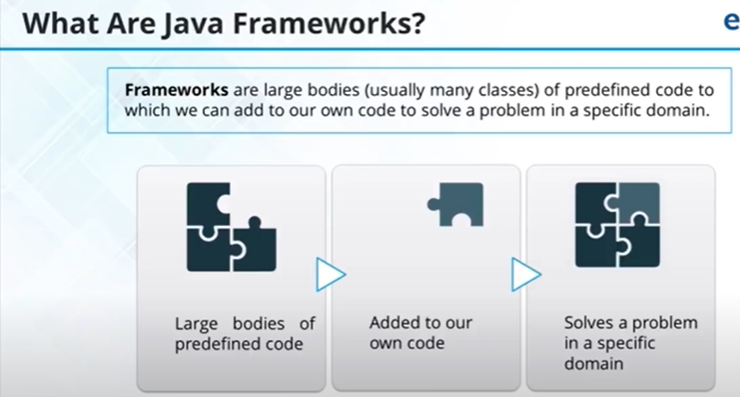

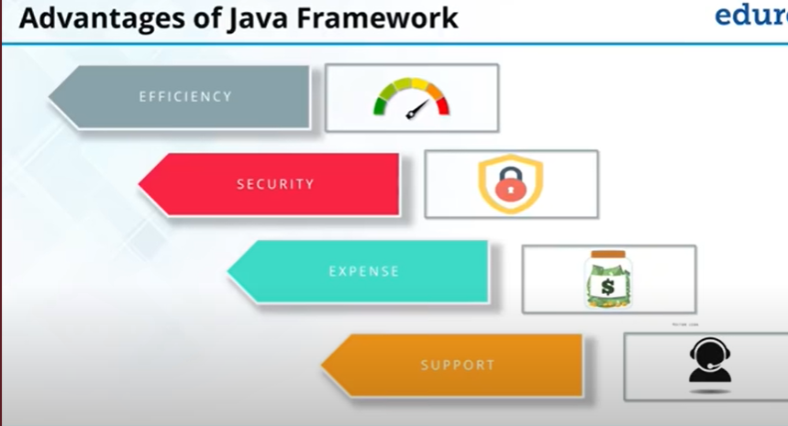

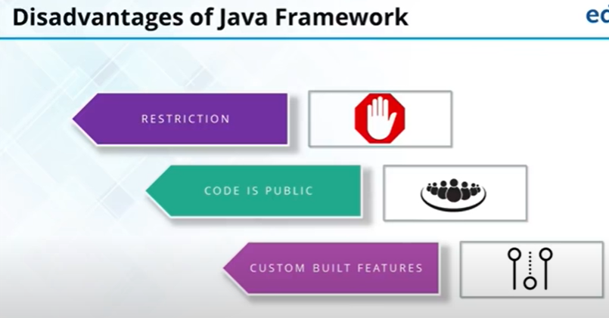

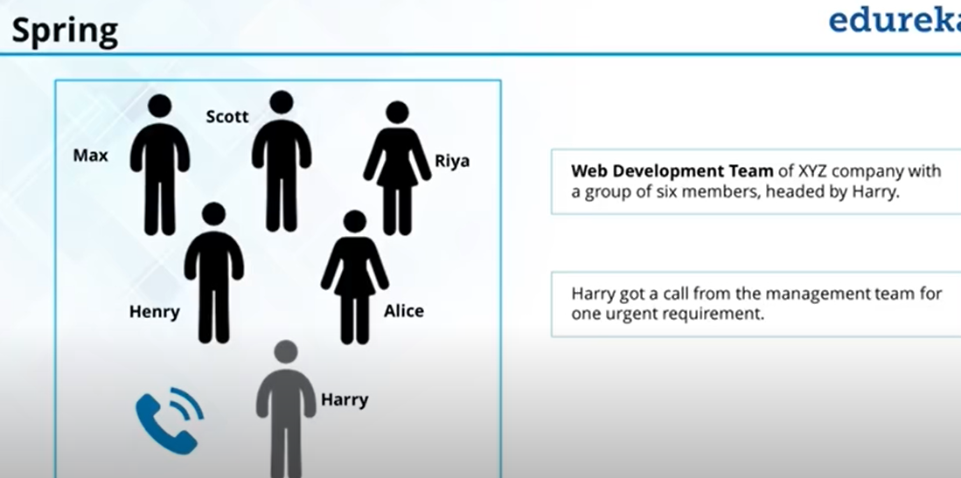

Manager calls Harry to submit the project in a limited time. So, Harry will use Frameworks, some of the employee says to use Hibernate, struts but one says Spring and Spring is the best one because it is the frameworks of framework, as it has features of the frameworks too.

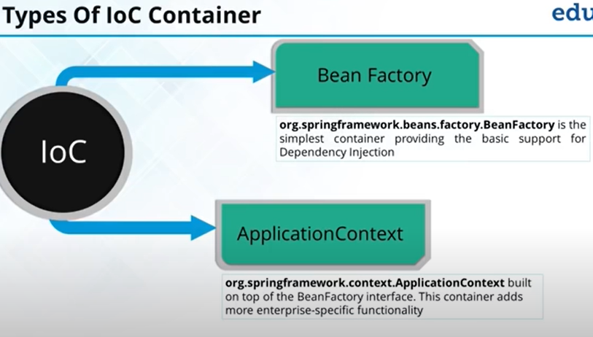

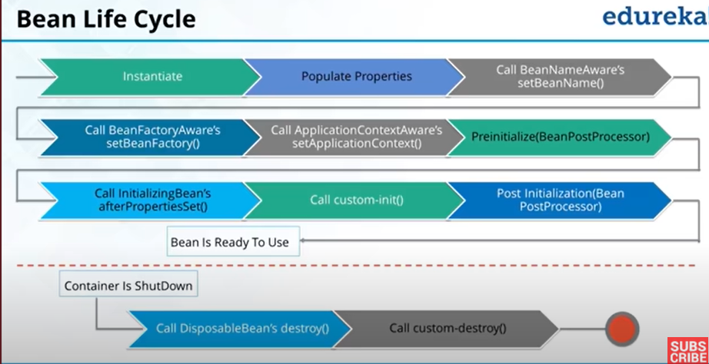

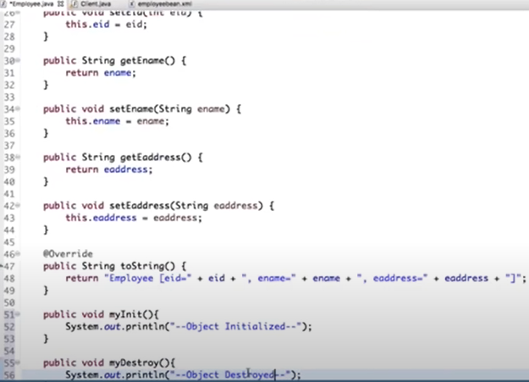

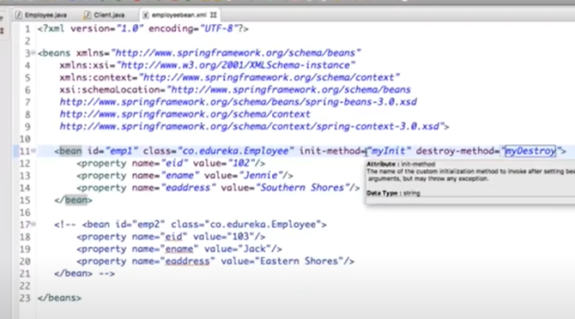

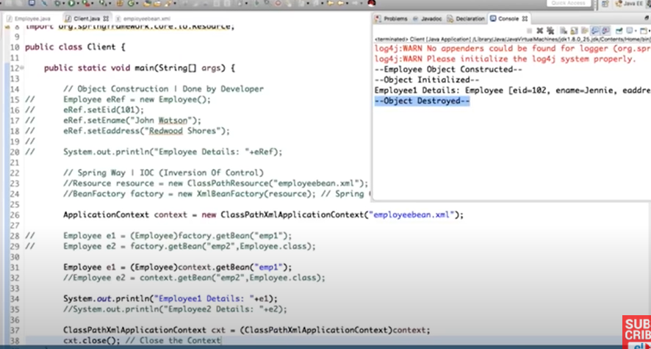

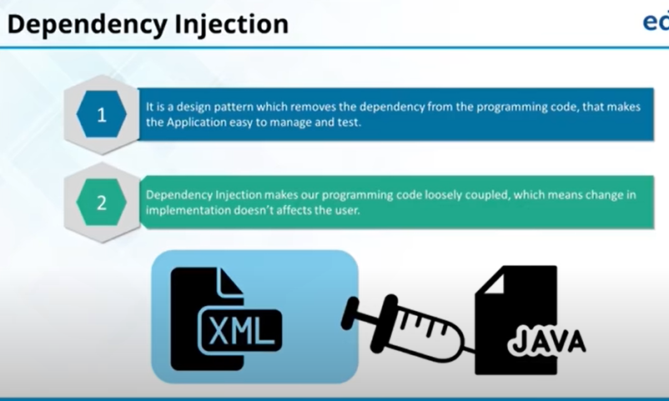

Injection either through setter or constructor:

Employee.java

package com.spring.SpringFramework;

public class Employee {

int eid;

String ename;

Address eaddress;

public Employee() {

System.***out***.println("Object constructed");

}

// consturctor injection

public Employee(Address eaddress) {

this.eaddress = eaddress;

}

public int getEid() {

return eid;

}

public void setEid(int eid) {

this.eid = eid;

}

public String getEname() {

return ename;

}

public void setEname(String ename) {

this.ename = ename;

}

public Address getEaddress() {

return eaddress;

}

// setter injection

public void setEaddress(Address eaddress) {

this.eaddress = eaddress;

}

public void myInit() {

System.***out***.println("Object initlaized");

}

public void myDestroy() {

System.***out***.println("Object destroyed");

}

*@Override*

public String toString() {

return "Employee [eid=" + eid + ", ename=" + ename + ", eaddress=" + eaddress + "]";

}

}

Address.java

package com.spring.SpringFramework;

public class Address {

String city;

String state;

int zipCode;

public Address() {

}

public Address(String city, String state, int zipCode) {

this.city = city;

this.state = state;

this.zipCode = zipCode;

}

public String getCity() {

return city;

}

public void setCity(String city) {

this.city = city;

}

public String getState() {

return state;

}

public void setState(String state) {

this.state = state;

}

public int getZipCode() {

return zipCode;

}

public void setZipCode(int zipCode) {

this.zipCode = zipCode;

}

*@Override*

public String toString() {

return "Address [city=" + city + ", state=" + state + ", zipCode=" + zipCode + "]";

}

}

Spring.xml

<?xml version="1.0" encoding="UTF-8"?>

<beans xmlns="http://www.springframework.org/schema/beans"

xmlns:xsi="http://www.w3.org/2001/XMLSchema-instance"

xmlns:context="http://www.springframework.org/schema/context"

xsi:schemaLocation="http://www.springframework.org/schema/beans

http://www.springframework.org/schema/beans/spring-beans.xsd

http://www.springframework.org/schema/context

http://www.springframework.org/schema/context/spring-context.xsd">

<!-- <context:component-scan base-package="com.spring.SpringFramework"></context:component-scan>-->

<!-- Define other beans or configurations as needed -->

<!--<bean id="tyre" class="com.spring.SpringFramework.Tyre">

<property name="brand" value="MRF"></property>

<constructor-arg value="MRF"></constructor-arg>

</bean>-->

<bean id="adrs" class="com.spring.SpringFramework.Address">

<property name="city" value="Haridwar"></property>

<property name="state" value="UK"></property>

<property name="zipCode" value="249403"></property>

</bean>

<bean id="emp1" class="com.spring.SpringFramework.Employee" init-method="myInit" destroy-method="myDestroy">

<property name="eid" value="103"></property>

<property name="ename" value="Jennie"></property>

<!--<property name="address" ref="adrs"></property>-->

<!--OR-->

<constructor-arg ref="adrs"></constructor-arg>

</bean>

</beans>

App.java

package com.spring.SpringFramework;

import org.springframework.context.ApplicationContext;

import org.springframework.context.annotation.AnnotationConfigApplicationContext;

import org.springframework.context.support.ClassPathXmlApplicationContext;

public class App {

public static void main(String[] args) {

ApplicationContext context = new ClassPathXmlApplicationContext("spring.xml");

/*

* Samsung s7 = factory.getBean(Samsung.class); s7.config();

*/

Employee e1 = (Employee) context.getBean("emp1");

System.out.println("employee details: " + e1);

ClassPathXmlApplicationContext cxt = (ClassPathXmlApplicationContext) context;

cxt.close();

}

}

Spring AOP Tutorial

**Aspect Oriented Programming** (AOP) compliments OOPs in the sense that it also provides modularity. But the key unit of modularity is aspect than class.

AOP breaks the program logic into distinct parts (called concerns). It is used to increase modularity by **cross-cutting concerns**.

A **cross-cutting concern** is a concern that can affect the whole application and should be centralized in one location in code as possible, such as transaction management, authentication, logging, security etc

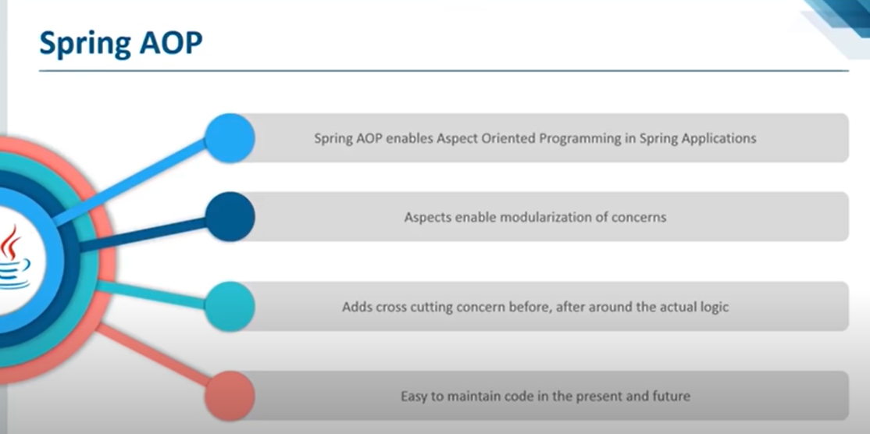

#### **Why use AOP?**

It provides the pluggable way to dynamically add the additional concern before, after or around the actual logic. Suppose there are 10 methods in a class as given below:

1. **class** A{
2. **public** **void** m1(){...}
3. **public** **void** m2(){...}
4. **public** **void** m3(){...}
5. **public** **void** m4(){...}
6. **public** **void** m5(){...}
7. **public** **void** n1(){...}
8. **public** **void** n2(){...}
9. **public** **void** p1(){...}
10. **public** **void** p2(){...}
11. **public** **void** p3(){...}
12. }

There are 5 methods that starts from m, 2 methods that starts from n and 3 methods that starts from p.

**Understanding Scenario** I have to maintain log and send notification after calling methods that starts from m.

**Problem without AOP** We can call methods (that maintains log and sends notification) from the methods starting with m. In such scenario, we need to write the code in all the 5 methods.

But, if client says in future, I don't have to send notification, you need to change all the methods. It leads to the maintenance problem.

**Solution with AOP** We don't have to call methods from the method. Now we can define the additional concern like maintaining log, sending notification etc. in the method of a class. Its entry is given in the xml file.

In future, if client says to remove the notifier functionality, we need to change only in the xml file. So, maintenance is easy in AOP.

## **AOP Concepts and Terminology**

AOP concepts and terminologies are as follows:

* Join point
* Advice
* Pointcut
* Introduction
* Target Object
* Aspect
* Interceptor
* AOP Proxy
* Weaving

#### **Join point**

Join point is any point in your program such as method execution, exception handling, field access etc. Spring supports only method execution join point.

#### **Advice**

Advice represents an action taken by an aspect at a particular join point. There are different types of advices:

* **Before Advice**: it executes before a join point.
* **After Returning Advice**: it executes after a joint point completes normally.
* **After Throwing Advice**: it executes if method exits by throwing an exception.
* **After (finally) Advice**: it executes after a join point regardless of join point exit whether normally or exceptional return.
* **Around Advice**: It executes before and after a join point.

#### **Pointcut**

It is an expression language of AOP that matches join points.

#### **Introduction**

It means introduction of additional method and fields for a type. It allows you to introduce new interface to any advised object.

#### **Target Object**

It is the object i.e. being advised by one or more aspects. It is also known as proxied object in spring because Spring AOP is implemented using runtime proxies.

#### **Aspect**

It is a class that contains advices, joinpoints etc.

#### **Interceptor**

It is an aspect that contains only one advice.

#### **AOP Proxy**

It is used to implement aspect contracts, created by AOP framework. It will be a JDK dynamic proxy or CGLIB proxy in spring framework.

#### **Weaving**

It is the process of linking aspect with other application types or objects to create an advised object. Weaving can be done at compile time, load time or runtime. Spring AOP performs weaving at runtime.

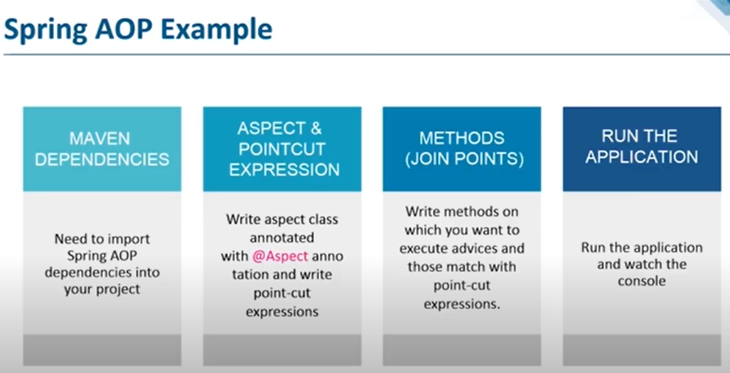

Spring AOP demo:

App.java

package com.spring.project.SpringAOP;

import org.springframework.context.ApplicationContext;

import org.springframework.context.support.ClassPathXmlApplicationContext;

public class App {

public static void main(String[] args) {

ApplicationContext appContext = new ClassPathXmlApplicationContext("Customer.xml");

CustomerService cust = (CustomerService) appContext.getBean("customerServiceProxy");

System.***out***.println("**********************");

cust.printName();

System.***out***.println("***********************");

cust.printUrl();

System.***out***.println("**********************");

try {

cust.printThrowException();

} catch (Exception e) {

}

}

}

customerService.java

package com.spring.project.SpringAOP;

public class CustomerService {

private String name;

private String url;

public void printName() {

System.***out***.println("Customer name: " + this.name);

}

public void setName(String name) {

this.name = name;

}

public void printUrl() {

System.***out***.println("Customer website: " + this.url);

}

public void setUrl(String url) {

this.url = url;

}

public void printThrowException() {

throw new IllegalArgumentException();

}

}

Customer.xml

<?xml version="1.0" encoding="UTF-8"?>

<beans xmlns="http://www.springframework.org/schema/beans"

xmlns:xsi="http://www.w3.org/2001/XMLSchema-instance"

xmlns:context="http://www.springframework.org/schema/context"

xsi:schemaLocation="http://www.springframework.org/schema/beans

http://www.springframework.org/schema/beans/spring-beans.xsd

http://www.springframework.org/schema/context

http://www.springframework.org/schema/context/spring-context.xsd">

<!-- Define other beans or configurations as needed -->

<bean id="customerService" class="com.spring.project.SpringAOP.CustomerService">

<property name="name" value="Vicky"></property>

<property name="url" value="https://www.edureka.co"></property>

</bean>

<bean id="hijackAfterMethodBean" class="com.spring.project.SpringAOP.HijackAfterMethod" />

<bean id="customerServiceProxy" class="org.springframework.aop.framework.ProxyFactoryBean" >

<property name="target" ref="customerService"></property>

<property name="interceptorNames" >

<list>

<value>hijackAfterMethodBean</value>

</list>

</property>

</bean>

</beans>

HijackAfterMethod.java

package com.spring.project.SpringAOP;  
import java.lang.reflect.Method;  
import org.springframework.aop.AfterReturningAdvice;

public class HijackAfterMethod implements AfterReturningAdvice {

@Override  
 public void afterReturning(Object returnValue, Method method, Object[] args, Object target) throws  
Throwable {  
System.out.println("HijackAfterMethod: after method hijacked!");  
}  
}

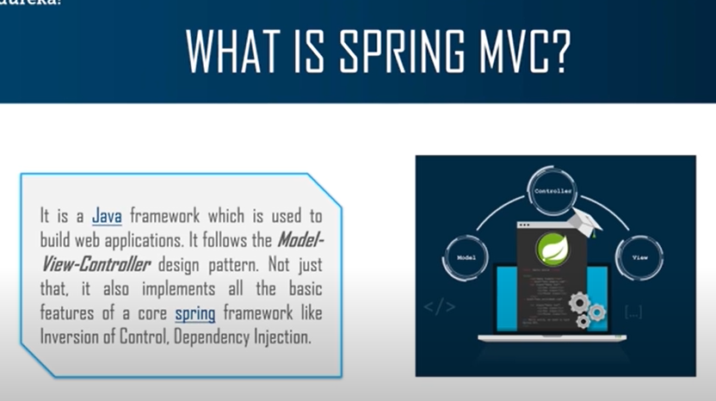

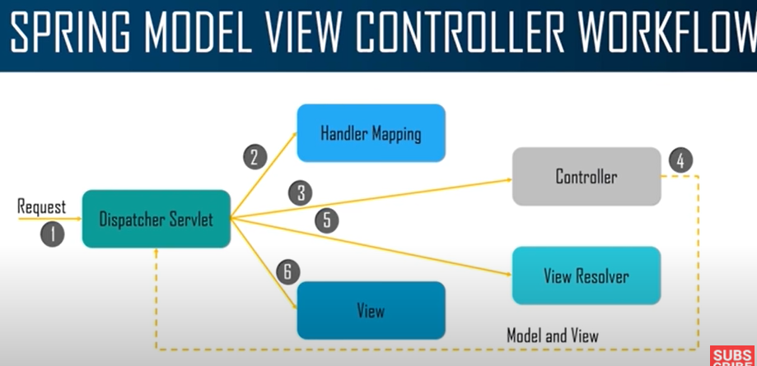

Spring MVC:

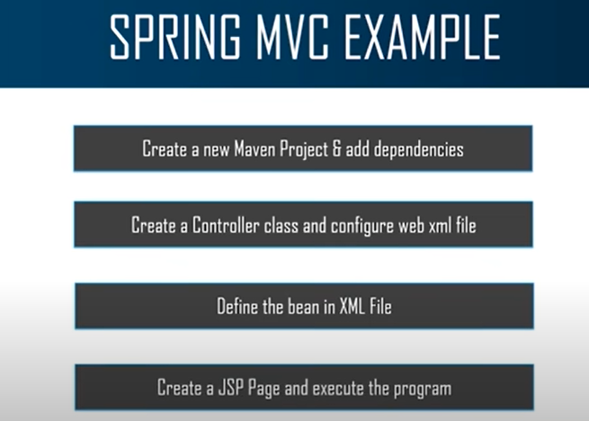

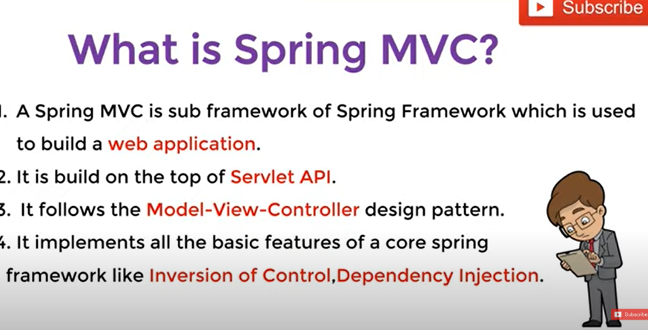

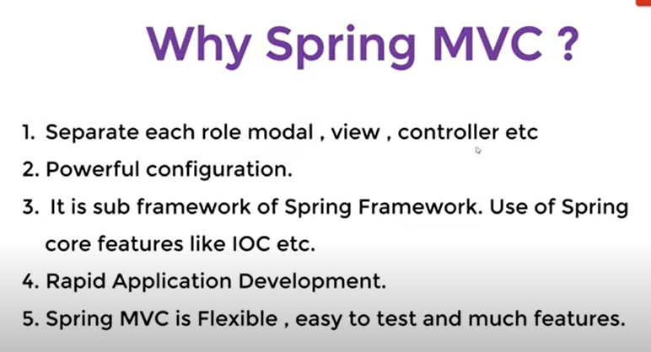

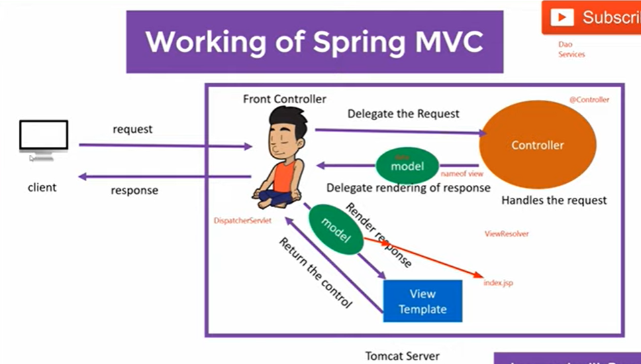

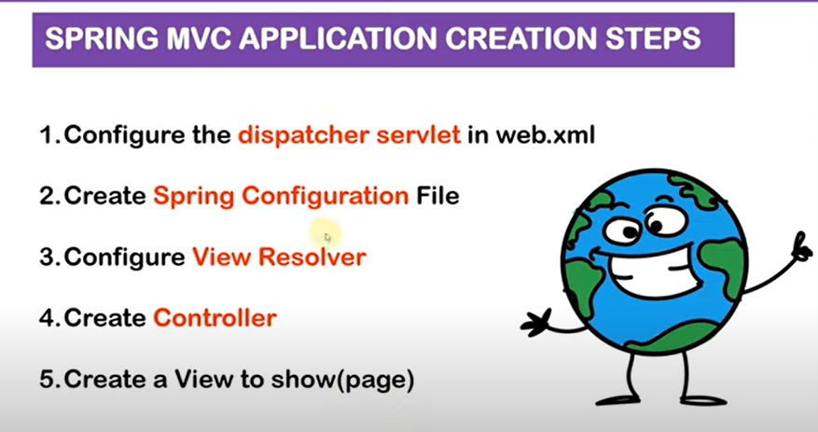

Demo:

Web.xml

<!DOCTYPE web-app PUBLIC

"-//Sun Microsystems, Inc.//DTD Web Application 2.3//EN"

"http://java.sun.com/dtd/web-app_2_3.dtd" >

<web-app>

<display-name>Archetype Created Web Application</display-name>

<servlet>

<servlet-name>telusko</servlet-name>

<servlet-class>org.springframework.web.servlet.DispatcherServlet</servlet-class>

</servlet>

<servlet-mapping>

<servlet-name>telusko</servlet-name>

<url-pattern>/</url-pattern>

</servlet-mapping>

</web-app>

AddController.java

package com.telusko;

import org.springframework.stereotype.Controller;

import org.springframework.web.bind.annotation.RequestMapping;

import org.springframework.web.servlet.ModelAndView;

import com.telusko.service.AddService;

import jakarta.servlet.http.HttpServletRequest;

import jakarta.servlet.http.HttpServletResponse;

*@Controller*

public class AddController {

*@RequestMapping*("/add")

public ModelAndView add(HttpServletRequest req,HttpServletResponse res) {

int i = Integer.*parseInt*(req.getParameter("t1"));

int j = Integer.*parseInt*(req.getParameter("t2"));

AddService as = new AddService();

int k = as.add(i, j);

ModelAndView mv = new ModelAndView();

mv.setViewName("display.jsp");

mv.addObject("result",k);

return mv;

}

}

telusko-servlet.xml

<?xml version="1.0" encoding="UTF-8"?>

<beans xmlns="http://www.springframework.org/schema/beans"

xmlns:xsi="http://www.w3.org/2001/XMLSchema-instance"

xmlns:context="http://www.springframework.org/schema/context"

xsi:schemaLocation="http://www.springframework.org/schema/beans

http://www.springframework.org/schema/beans/spring-beans.xsd

http://www.springframework.org/schema/context

http://www.springframework.org/schema/context/spring-context.xsd">

<context:annotation-config></context:annotation-config>

<context:component-scan base-package="com.telusko"></context:component-scan>

</beans>

AddService.java

package com.telusko.service;

public class AddService {

public int add(int i, int j) {

return i + j;

}

}

Index.jsp

<**html**>

<**body**>

<**form** action=*"add"*>

<**input** type = *"text"* name = *"t1"*><**br**>

<**input** type = *"text"* name = *"t2"*><**br**>

<**input** type = *"submit"*>

</**form**>

</**body**>

</**html**>

Display.jsp

<%@ **page** language=*"java"* contentType=*"text/html; charset=ISO-8859-1"*

pageEncoding=*"ISO-8859-1"*%>

<!**DOCTYPE** html>

<**html**>

<**head**>

<**meta** charset=*"ISO-8859-1"*>

<**title**>Insert title here</**title**>

</**head**>

<**body**>

Result is : <%= request.getAttribute("result") %>

</**body**>

</**html**>

Certainly! Spring MVC is a popular framework for building web applications in Java. It follows the Model-View-Controller (MVC) architectural pattern, which separates the application into three main components: Model, View, and Controller. Here's how the flow of a Spring MVC application works based on the code you provided:

1. **Client Request**:

- A client (usually a web browser) sends a request to the web application. In your example, when you access the URL where this Spring MVC application is deployed, the request is initially handled by the `web.xml` configuration.

2. **`web.xml` Configuration**:

- The `web.xml` file is the deployment descriptor for the web application. It configures the servlets and servlet mappings. In your `web.xml`, you have configured a servlet named "telusko" with a mapping of "/*". This means that all incoming requests will be handled by the DispatcherServlet.

3. **DispatcherServlet**:

- The DispatcherServlet is the front controller of the Spring MVC application. It receives all incoming requests and acts as a traffic cop, directing the request to the appropriate controller.

4. **`AddController`**:

- In your code, you have a controller class named `AddController`. This controller is responsible for handling the "/add" URL pattern.

5. **`@RequestMapping` Annotation**:

- The `@RequestMapping` annotation is used to map a URL to a specific method in the controller. In your `AddController`, the `@RequestMapping("/add")` annotation maps the "/add" URL to the `add` method.

6. **`add` Method**:

- When a request is made to the "/add" URL, the `add` method in the `AddController` is invoked. This method:

- Retrieves the values of "t1" and "t2" parameters from the request using `req.getParameter()`.

- Calls the `AddService` to perform the addition operation.

- Creates a `ModelAndView` object, sets the view name to "display.jsp," and adds the result of the addition as an attribute.

7. **View Resolver**:

- Spring MVC uses a View Resolver to map logical view names to physical view files. In your configuration, it's not explicitly shown, but typically, you would configure a View Resolver in your `telusko-servlet.xml` to resolve "display.jsp" to the actual JSP file.

8. **View Rendering**:

- The DispatcherServlet identifies the view resolver and uses it to find the "display.jsp" file. It then renders the JSP with the model data (the result of the addition) and sends the HTML response back to the client.

9. **Client Response**:

- The client (web browser) receives the HTML response generated by the JSP and displays it to the user.

In summary, the flow of a Spring MVC application involves the DispatcherServlet routing incoming requests to the appropriate controller, where business logic is executed. The controller prepares data and specifies the view, which is then rendered and sent back to the client. This separation of concerns and the MVC architecture helps in creating maintainable and scalable web applications.

**When we don’t want to use xml configuration, we go for annotation-based configuration:**

Telusko-servlet.xml replacement is teluskoConfig.java and web.xml replacement is MyWebInitializer.java (front controller)

AddController.java

package com.telusko;

import org.springframework.stereotype.Controller;

import org.springframework.web.bind.annotation.RequestMapping;

import org.springframework.web.bind.annotation.RequestParam;

import org.springframework.web.servlet.ModelAndView;

import com.telusko.service.AddService;

import jakarta.servlet.http.HttpServletRequest;

import jakarta.servlet.http.HttpServletResponse;

*@Controller*

public class AddController {

*@RequestMapping*("/add")

public ModelAndView add(*@RequestParam*("t1") int i, *@RequestParam*("t2") int j,HttpServletRequest req,HttpServletResponse res) {

/* when i use requestparam there is no use of below lines

* int i = Integer.parseInt(req.getParameter("t1")); int j =

* Integer.parseInt(req.getParameter("t2"));

*/

AddService as = new AddService();

int k = as.add(i, j);

ModelAndView mv = new ModelAndView();

mv.setViewName("display");

mv.addObject("result",k);

return mv;

}

}

teluskoConfig.java

package com.telusko;

import org.springframework.context.annotation.Bean;

import org.springframework.context.annotation.ComponentScan;

import org.springframework.context.annotation.Configuration;

import org.springframework.web.servlet.view.InternalResourceViewResolver;

*@Configuration*

*@ComponentScan*({"com.telusko"})

public class TeluskoConfig {

*@Bean*

public InternalResourceViewResolver viewResolver() {

InternalResourceViewResolver vr = new InternalResourceViewResolver();

vr.setPrefix("/WEB-INF/");

//In future we can change the view extension

vr.setSuffix(".jsp");

return vr;

}

}

**MyWebInitializer.java(front controller)**

package com.telusko;

import org.springframework.web.servlet.support.AbstractAnnotationConfigDispatcherServletInitializer;

public class MyWebInitializer extends AbstractAnnotationConfigDispatcherServletInitializer {

*@Override*

protected Class<?>[] getRootConfigClasses() {

// **TODO** Auto-generated method stub

return null;

}

*@Override*

protected Class<?>[] getServletConfigClasses() {

// **TODO** Auto-generated method stub

return new Class[] {TeluskoConfig.class};

}

*@Override*

protected String[] getServletMappings() {

// **TODO** Auto-generated method stub

return new String[] {"/"};

}

}

In your provided code, which is based on the Spring MVC framework, here's how the components correspond to the MVC pattern:

1. **Front Controller**:

- The "Front Controller" in your code is the `DispatcherServlet`, configured in the `MyWebInitializer.java` class. It acts as the central entry point for all incoming HTTP requests to your web application, and it delegates requests to the appropriate controllers based on the URL mapping. The `getServletConfigClasses` method specifies the configuration class for the DispatcherServlet, which is `TeluskoConfig`.

2. **Controller**:

- The "Controller" in your code is the `AddController` class, annotated with `@Controller`. This class contains the `add` method, which handles the "/add" URL. The `add` method processes incoming requests, interacts with the model (in this case, `AddService`), and prepares data for the view. It also returns a `ModelAndView` object to specify the view to render.

3. **Model**:

- The "Model" in your code is represented by the `AddService` class. It contains the business logic to perform the addition operation. This class encapsulates the logic and data manipulation required for this specific operation. In a larger application, you might have more complex models representing various aspects of your application's data and business logic.

4. **View**:

- The "View" in your code is the "display.jsp" file. This JSP file is responsible for presenting the result (data) to the user in an HTML format. It uses JSP syntax to embed dynamic data from the model into the HTML response. The view resolver in your `TeluskoConfig` class is responsible for resolving the logical view name ("display") to the physical JSP file.

In summary:

- The `DispatcherServlet` (`MyWebInitializer.java`) serves as the "Front Controller."

- The `AddController` class acts as the "Controller" and handles request processing.

- The `AddService` class represents the "Model" and contains the business logic.

- The "display.jsp" file serves as the "View" and is responsible for rendering the result to the user.